Adobe Animate CC Simulations

- You are designing an interactive entertainment guide for a city. When your user clicks the Scenic Attractions button, you’d like it to play the fade-in animation starting on frame 10 through frame 19. Use Code Snippets for ActionScript 3.0 to attach the appropriate navigation Code Snippet to the Scenic Attractions button and modify its default parameter to start playing the animation from frame 10. Add another Code Snippet to stop the animation when it reaches frame 19.
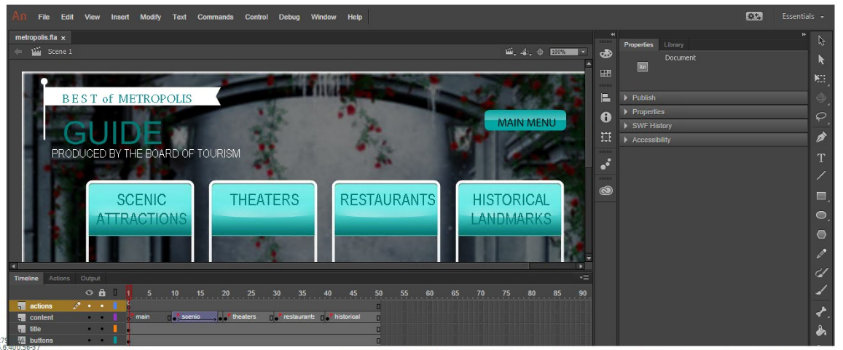
- A project is being translated into Spanish. The submit button needs to be imported to match the rest of the text on the Sign in form. Import the submit-buttons graphic to the stage, retaining the original position. This will add 2 submit buttons, one in English and one in Spanish. Delete the button that reads Submit in English, and keep the button that reads Submit in Spanish.
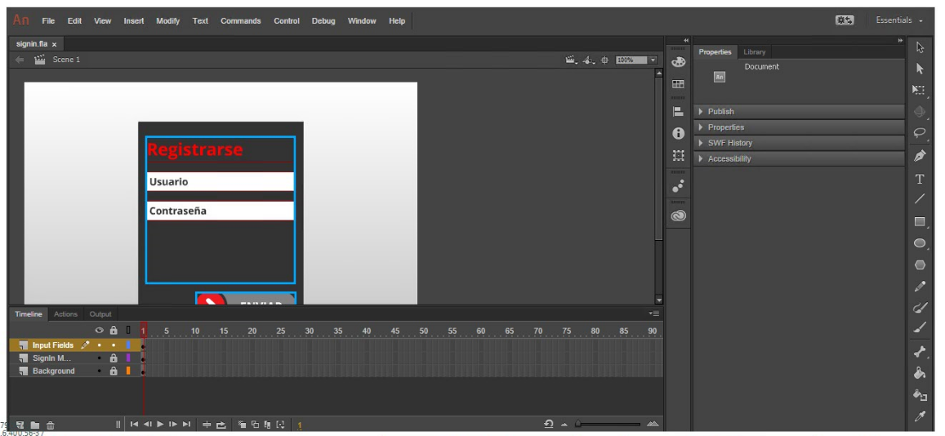
- You are designing an interactive entertainment guide for the imaginary city of Metropolis. Create a Fade-in tween animation so that the Scenic Attractions fades in, from completely invisible on frame 10 to completely visible on frame 19.
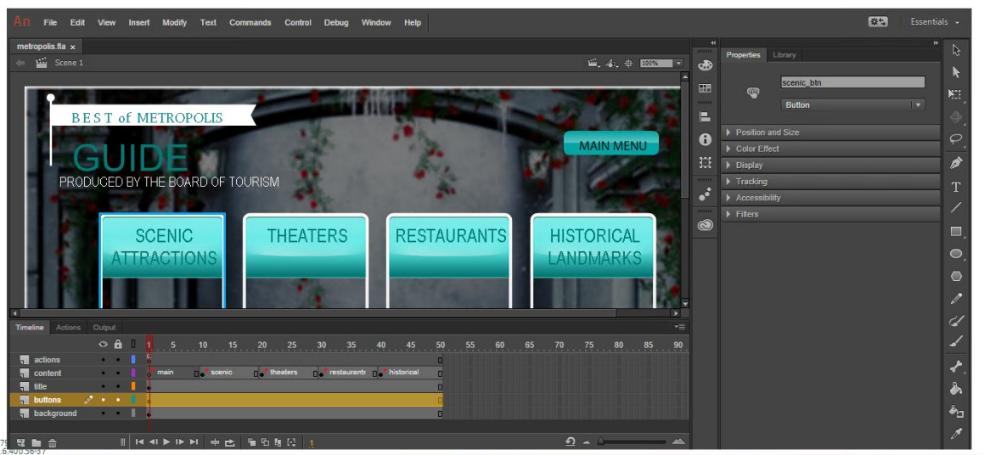

- Give the sections in the content layer on the timeline labels by labeling the keyframes of each. Use these labels: main, scenic, theaters, restaurants and historical.
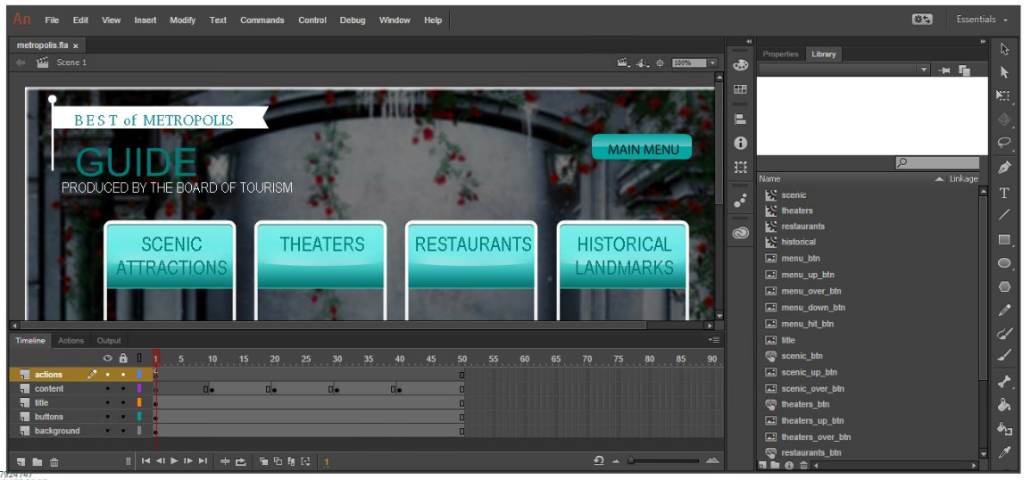

- Use the Layer Properties to make the text-graphic on the layer kahuna to mask the waves layer immediately below it. When you are finished, the letters in the kahuna image will be filled with the waves.
